Software Architecture and Design Specification
Vehicle Parking System (VPS)
Project: Vehicle Parking System (VPS) — Team 10
Version: 1.0
Authors: BR Manasi (PES2UG24CS104), BR Manavi (PES2UG24CS105), B Meghana (PES2UG24CS103), B Sanjana (PES2UG24CS106)
Date: 16-09-2026
Status: Draft

Revision History
Version | Date | Author | Change Summary
1.0 | 16-09-2026 | Manasi, Manavi, Meghana, Sanjana | Initial SAD draft, derived from VPS SRS v1.0 and VPS Test Plan v1.0

Approvals
Role | Name | Signature / Date
QA Lead | BR Manasi | 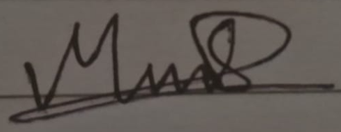
Dev Lead | B SANJANA | 
Product Owner | BR MANAVI | 
Product Owner | B MEGHANA | 

1. Introduction

1.1 Purpose
This document specifies the software architecture and design of the Vehicle Parking System (VPS), a web (and optionally mobile) application for managing parking slots and vehicle tracking. It is derived from the VPS Software Requirements Specification (SRS) v1.0 and is aligned with the VPS Test Plan v1.0, and it defines the architectural building blocks, component design, API contracts, and security architecture needed for implementation and verification.

1.2 Scope
This document covers the architecture and design of: user registration and authentication; parking slot search and reservation; vehicle entry/exit logging and real-time occupancy tracking (simulated in software, as no physical ANPR/IoT hardware is available to the team); payment and billing via a sandboxed payment gateway; administrative management of parking lots, slots and pricing; and notifications and reporting. Consistent with the SRS, it excludes physical construction of parking infrastructure, integration with unrelated third-party municipal traffic systems, and the internal workings of the payment gateway, Maps API and SMS/Email providers.

1.3 Audience
Developers, QA Engineers, System Integrators, Parking Facility Operators, and Assessment Evaluators.

1.4 Definitions
VPS (Vehicle Parking System), UI (User Interface), API (Application Programming Interface), ANPR (Automatic Number Plate Recognition), IoT (Internet of Things), JWT (JSON Web Token), REST (Representational State Transfer), DB (Database), OTP (One-Time Password), TLS (Transport Layer Security), RBAC (Role-Based Access Control), ADR (Architecture Decision Record), PCI-DSS (Payment Card Industry Data Security Standard).

2. Document Overview

2.1 How to use this document
Provides the architectural deliverables for the VPS: a component (UML) diagram, two UML sequence diagrams for representative flows, an architecture-pattern rationale, a STRIDE-based threat model, and the API design for the core booking, tracking and payment endpoints.

2.2 Related Documents
VPS Software Requirements Specification (SRS) v1.0 — Team 10; VPS Test Plan v1.0 — Team 10; Requirements Traceability Matrix (RTM), maintained in SRS Section 8 and Test Plan Section 13.

3. Architecture

3.1 Goals & Constraints
Goals: secure handling of user, vehicle and payment data; 99.5% monthly availability (VPS-NF-002); end-to-end response time ≤ 3 seconds for 90% of requests (VPS-NF-001); support for at least 500 concurrent users without degradation of core booking functions (VPS-NF-003); WCAG 2.1 AA accessible UI (VPS-NF-005).
Constraints: implementation must use the JavaScript (MERN) or Python (Flask/Django) stack (per SRS 2.5); payment processing must be delegated to a PCI-DSS compliant, tokenized gateway rather than storing raw card data; the project must be delivered within an academic timeline by a 4-member student team; no physical ANPR camera, IoT occupancy sensors or boom-barrier hardware is available, so entry/exit and occupancy events are simulated through the UI and a mock API trigger.

3.2 Stakeholders & Concerns
Stakeholder | Concerns
Driver / Customer | Fast slot discovery, reliable reservation, short entry/exit and payment times
Parking Attendant / Operator | Simple manual-entry and override UI, gate kiosk usability
Administrator | Lot/slot/pricing configuration, live occupancy dashboards, reporting
Regulators / Compliance | PCI-DSS compliance, protection of PII (contact details, vehicle registration numbers)
Developers / QA | Modularity, testability across unit / integration / system / security levels

3.3 Component (UML) Diagram
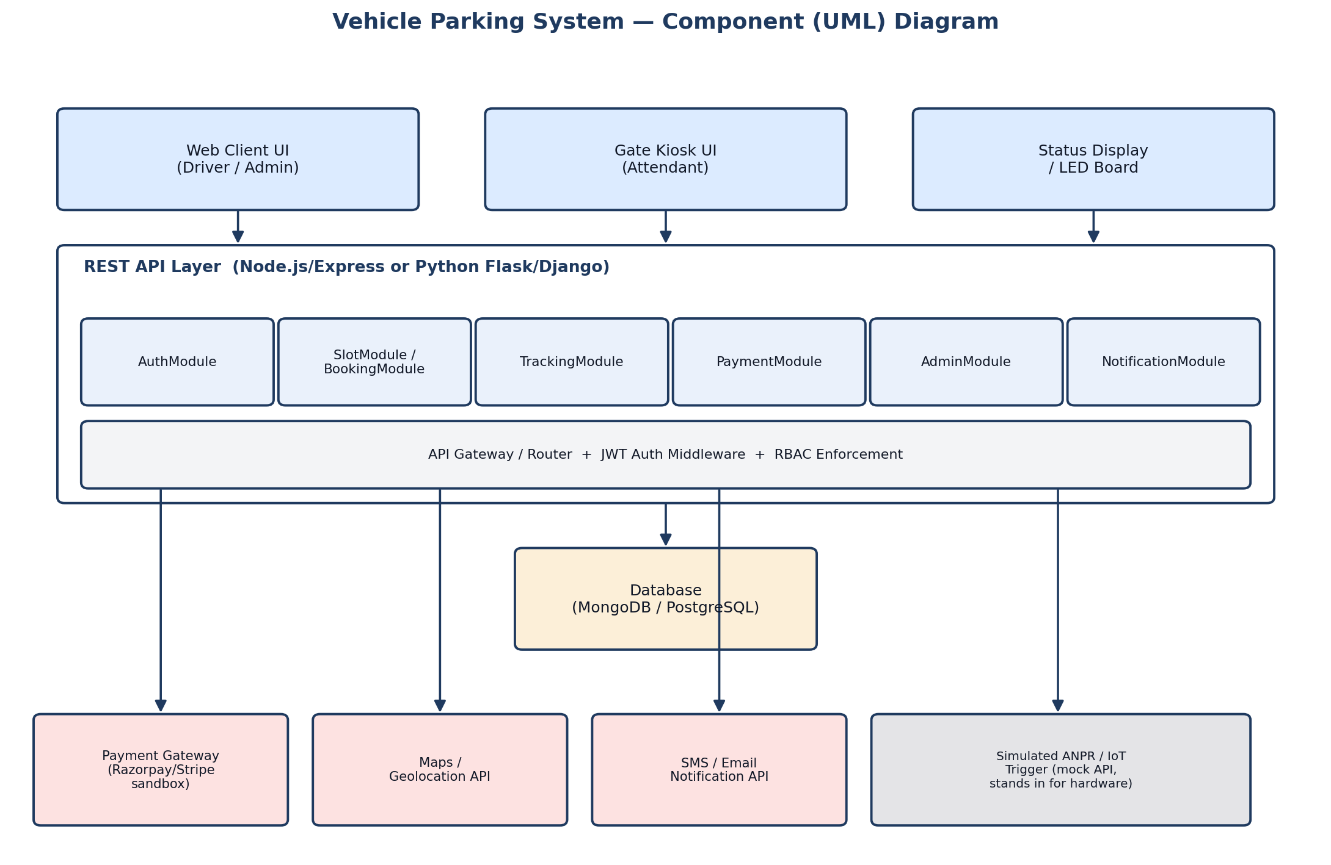

3.4 Component Descriptions
- Web Client UI: responsive web application for drivers and administrators, with screen-reader friendly prompts and a high-contrast mode.
- Gate Kiosk UI: touch-optimized interface for attendants at entry/exit points, used for manual entry and simulated scan triggers.
- Status Display / LED Board: shows live slot availability, fed by the Tracking Module.
- REST API Layer (Node.js/Express or Python Flask/Django): exposes endpoints and hosts an API gateway/router with JWT authentication middleware and RBAC enforcement.
- AuthModule: registration, login, JWT session issuance, OTP-based password reset, account lockout after 5 failed attempts, and role-based dashboards.
- SlotModule / BookingModule: slot search and filtering, real-time availability, reservation creation/cancellation, and prevention of double-booking via overlap checks.
- TrackingModule: vehicle entry/exit logging (manual or simulated ANPR trigger), matching against active reservations, real-time occupancy updates, and unauthorized-vehicle alerts.
- PaymentModule: fee calculation from duration and rate, tokenized charge via the payment gateway, digital receipts, and refunds for cancellations.
- AdminModule: creation/updating of parking lots and slots, pricing rules, attendant account management, and live occupancy dashboards.
- NotificationModule: SMS/email notifications for booking, entry, exit and payment events, plus periodic occupancy and revenue reports.
- Database (MongoDB / PostgreSQL): persists accounts, lots, slots, reservations, transactions and the administrative audit log; never stores raw card data.
- External integrations: Payment Gateway (Razorpay/Stripe, sandbox/test-mode), Maps/Geolocation API, SMS/Email notification API, and a simulated ANPR/IoT trigger endpoint standing in for physical hardware.

3.5 Chosen Architecture Pattern and Rationale
A layered, modular-monolith REST API architecture was chosen, with clear module boundaries (Auth, Slot/Booking, Tracking, Payment, Admin, Notification) behind a single API gateway. This gives clear separation of concerns and fast delivery for an academic timeline while keeping each module independently testable, matching the Test Plan's module-level test items. A microservices architecture was considered and rejected: it would add deployment and operational complexity (service discovery, inter-service auth, distributed tracing) that is unwarranted for the project's scale and the team's 4-person capacity, while the chosen module boundaries still leave a clear path to splitting out services later if load requires it.

3.6 Technology Stack & Data Stores
Frontend: responsive web client plus a kiosk-mode UI for attendants. Backend: Node.js/Express or Python Flask/Django, exposing a REST/JSON API, with WebSocket (or polling) for real-time slot-availability updates. Data store: MongoDB or PostgreSQL. Payment: Razorpay/Stripe in sandbox/test mode with tokenization. Communications: HTTPS with TLS 1.2+ enforced end to end, and a retry/backoff strategy for transient failures in payment and notification calls.

3.7 Risks & Mitigations
Risk | Mitigation
Real-time slot-availability latency is hard to reproduce/guarantee in the test environment | WebSocket-based updates validated with JMeter under production-like data volume
Concurrency defects (double-booking) missed in manual testing | Database-level locking/transactions on reservation writes, plus automated parallel-request tests
No physical ANPR camera or IoT sensors available | Mock trigger API abstraction layer simulates scan/sensor events, with a clean seam for real hardware integration later
Payment gateway sandbox unavailable or rate-limited | Mock payment service stub; gateway tests scheduled in defined windows
Test/production environment downtime | Backup environment on a cloud VM with a restorable database snapshot

3.8 Traceability to Requirements
Req ID(s) | Requirement Area | Component
VPS-F-001..005 | Registration, authentication, RBAC, lockout, OTP reset | AuthModule
VPS-F-010..014 | Slot search, availability, reservation, cancellation, double-booking prevention | SlotModule / BookingModule
VPS-F-020..025 | Vehicle entry/exit logging, reservation matching, unauthorized-vehicle alerts | TrackingModule
VPS-F-030..032 | Fee calculation, payment processing, receipts, refunds | PaymentModule
VPS-F-040..043 | Lot/slot/pricing management, occupancy dashboards, attendant accounts | AdminModule
VPS-F-050..052 | Booking/entry/exit/payment notifications, occupancy & revenue reports | NotificationModule
VPS-NF-001, VPS-NF-003 | Response time and 500-concurrent-user scalability | REST API layer / Database indexing
VPS-SR-001..005 | TLS enforcement, password hashing, RBAC, payment tokenization, audit logging | Infra / AuthModule / PaymentModule

3.9 Security Architecture
Threat modeling follows STRIDE, mapped to the VPS security requirements (SRS 5.1.2):
- Spoofing → JWT-based authentication and RBAC; OTP-verified password reset (VPS-F-003).
- Tampering → TLS 1.2+ on all connections (VPS-SR-001), server-side validation of reservation and payment data.
- Repudiation → audit log of administrative actions with timestamp and actor identity (VPS-SR-005).
- Information Disclosure → TLS everywhere; salted bcrypt password hashes, never plaintext (VPS-SR-002); no raw card data stored, tokenized gateway only (VPS-SR-004).
- Denial of Service → account lockout after 5 consecutive failed logins (VPS-F-004); rate limiting on authentication and booking endpoints.
- Elevation of Privilege → server-side RBAC restricting admin/attendant functions, returning HTTP 403 to unauthorized roles (VPS-SR-003).

4. Design

4.1 Design Overview
VPS is designed as a set of loosely-coupled modules (Auth, Slot/Booking, Tracking, Payment, Admin, Notification) behind a single REST API layer, sharing one relational/document database. This separation of concerns keeps each module independently unit-testable (per the Test Plan's unit/integration/system/acceptance levels) while a shared API gateway centralizes authentication, RBAC and rate limiting.

4.2 UML Sequence Diagrams
Two sequence diagrams are provided below, covering the two flows most central to the project: slot search and reservation, and the vehicle entry → payment → exit flow.
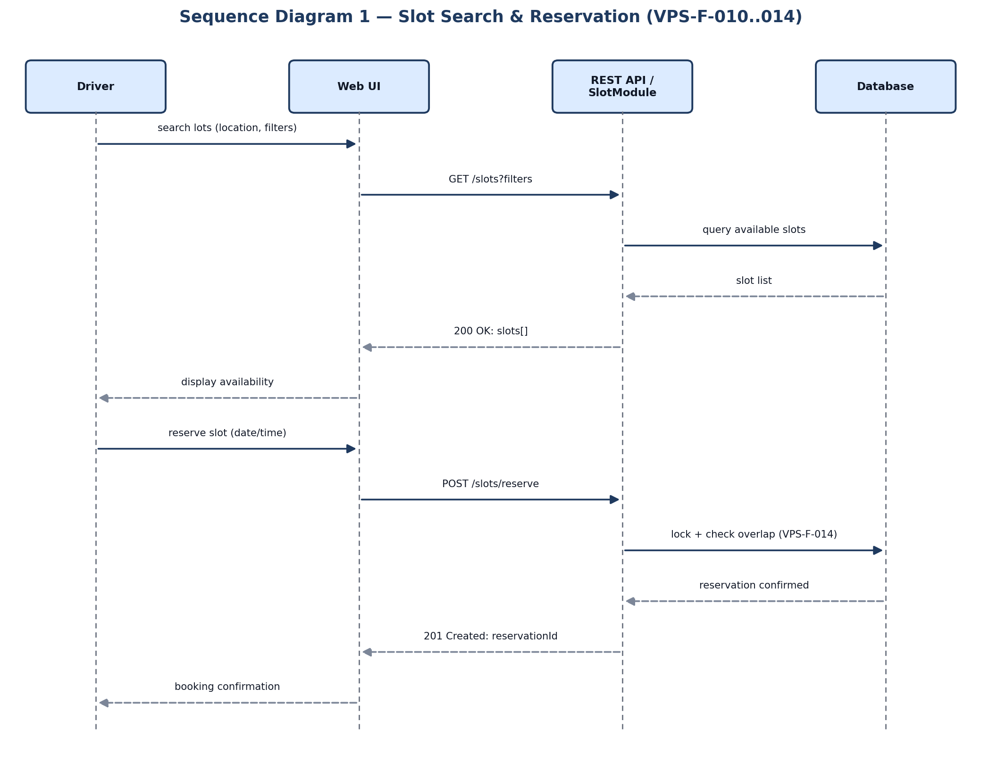
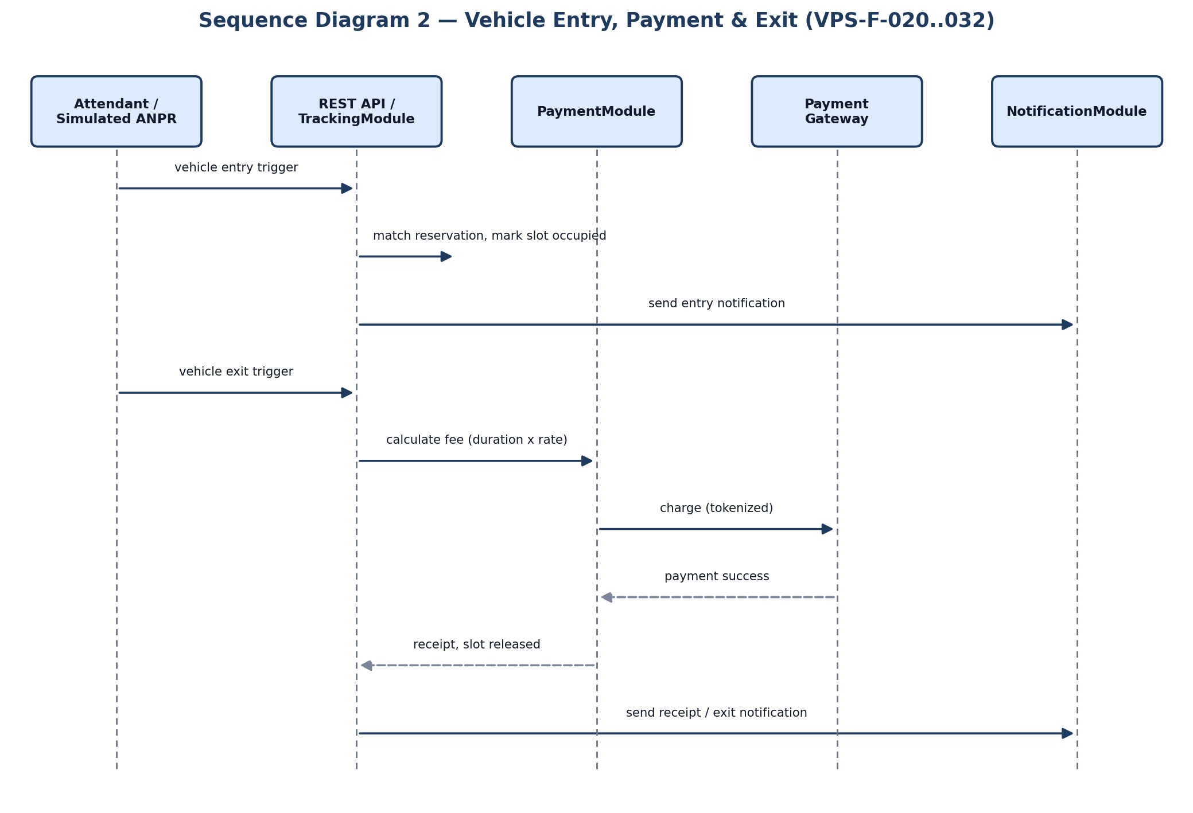

4.3 API Design
Representative endpoints for the Slot/Booking, Payment and Tracking modules:
Endpoint: POST /api/slots/reserve
Method: POST
Request: { userId, lotId, slotId, startTime, endTime }
Response: { status, reservationId, expiresAt }
Errors: 401 Unauthenticated; 409 Slot already reserved for the requested window (double-booking, VPS-F-014); 400 Invalid time window.
Endpoint: POST /api/payments/charge
Method: POST
Request: { reservationId, amount, paymentToken }
Response: { status, receiptId, balanceDue }
Errors: 401 Invalid session; 402 Payment failed; 404 Reservation not found.
Endpoint: POST /api/tracking/entry
Method: POST
Request: { gateId, vehicleNumber, reservationId (optional), triggerSource }
Response: { status, slotId, occupiedAt }
Errors: 401 Unauthenticated; 403 Unauthorized gate/attendant; 409 Unregistered/unauthorized vehicle alert raised.

4.4 Error Handling, Logging & Monitoring
All API errors use a standardized JSON error format ({ status, code, message }). Logs never include passwords, payment card data, or full vehicle-owner PII. Monitored metrics include: booking success rate, payment failure rate, API response time (90th percentile against the 3-second target), occupancy-tracking accuracy, and monthly uptime against the 99.5% target.

4.5 UX Design
Web Client UI: accessible font sizes, language selection, screen-reader friendly prompts, and a high-contrast mode conforming to WCAG 2.1 AA. Gate Kiosk UI: touch-optimized with large buttons and a minimal number of steps for attendant entry/exit overrides.

4.6 Open Issues & Next Steps
- Integrate real ANPR cameras and IoT occupancy sensors in place of the current simulated/mock trigger.
- Native mobile app for drivers, complementing the responsive web client.
- Dynamic/demand-based pricing for high-occupancy lots.
- Multi-lot chain management for operators running several facilities.

5. Appendices

5.1 Glossary
VPS, UI, API, ANPR, IoT, JWT, REST, DB, OTP, TLS, RBAC, ADR, PCI-DSS.

5.2 References
Vehicle Parking System SRS v1.0 (Team 10); Vehicle Parking System Test Plan v1.0 (Team 10); IEEE 42010; OWASP Top 10; NIST SP 800-160; PCI-DSS; WCAG 2.1 AA.

5.3 Tools
PlantUML / draw.io (diagrams); Postman and Swagger-style API documentation; Selenium / Cypress (UI automation); JMeter (performance/load); Jest / PyTest (unit testing); OWASP ZAP (security scanning); axe DevTools (accessibility); Jira (defect tracking); Git (version control).

